|  |  |
| --- | --- |
| Semester | T.E. Semester V – Computer Engineering |
| Subject | Software Engineering |
| Subject Professor In-charge | Prof. Sneha Annappanavar |
| Assisting Teachers | Prof. Sneha Annappanavar |
| Laboratory | M313B |

|  |  |
| --- | --- |
| Student Name | Deep Salunkhe |
| Roll Number | 21102A0014 |
| TE Division | A |

**Title:** **Introduction to Flutter**



**Explanation:**

Flutter is an open-source UI framework created by Google that allows you to build beautiful, high-performance apps for mobile (Android and iOS), web, and desktop (Windows, macOS, Linux) using a single codebase.

Here's a breakdown of some key points about Flutter:

* **Built with Widgets:** Everything in Flutter is built using widgets, which are reusable building blocks that represent a part of the UI. You can think of them like Legos for your app. By composing these widgets together, you can create complex and interactive UIs.
* **Dart Language:** Unlike many other mobile frameworks that rely on JavaScript, Flutter uses Dart, a modern object-oriented language known for its ease of learning and development speed.
* **Single Codebase:** One of the biggest advantages of Flutter is its ability to write code once and deploy it across multiple platforms. This saves developers a significant amount of time and effort compared to developing separate native apps for each platform.
* **Hot Reload:** Flutter features a super helpful function called hot reload, which allows you to see the changes you make to your code reflected in the app in real-time without having to restart the app. This significantly improves development efficiency.
* **Performance:** Flutter apps are known for their smooth performance and fast rendering. This is because Flutter uses its own rendering engine, which bypasses the need for platform-specific UI components.



**Implementation:**

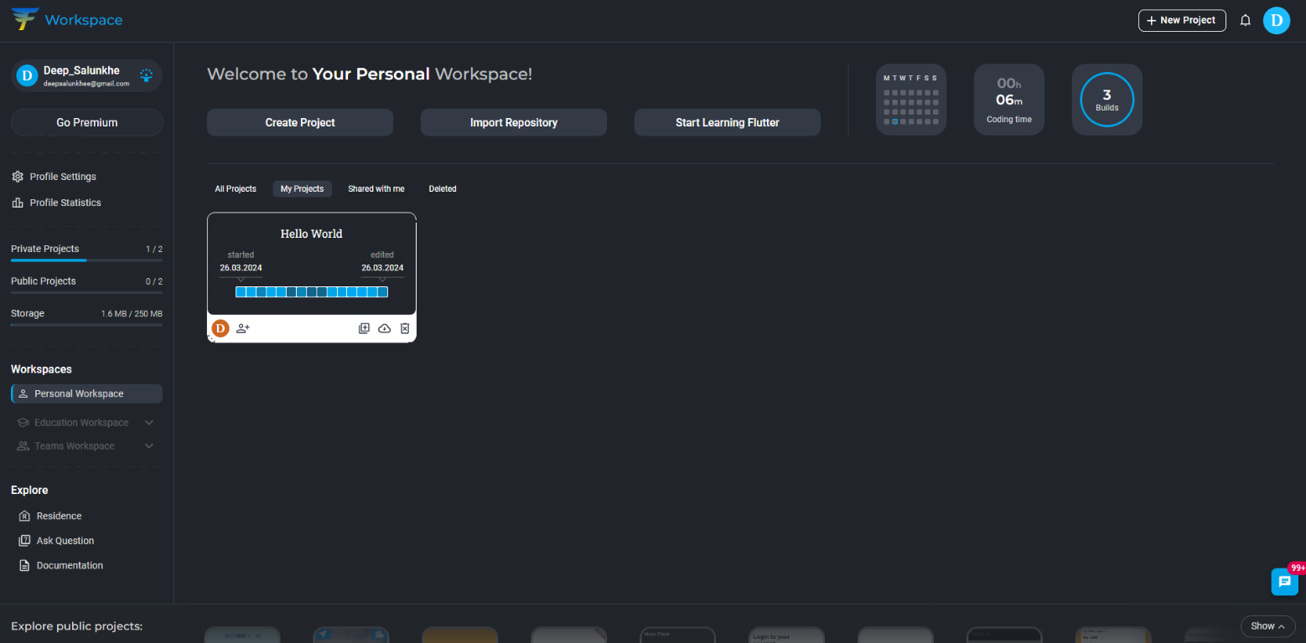



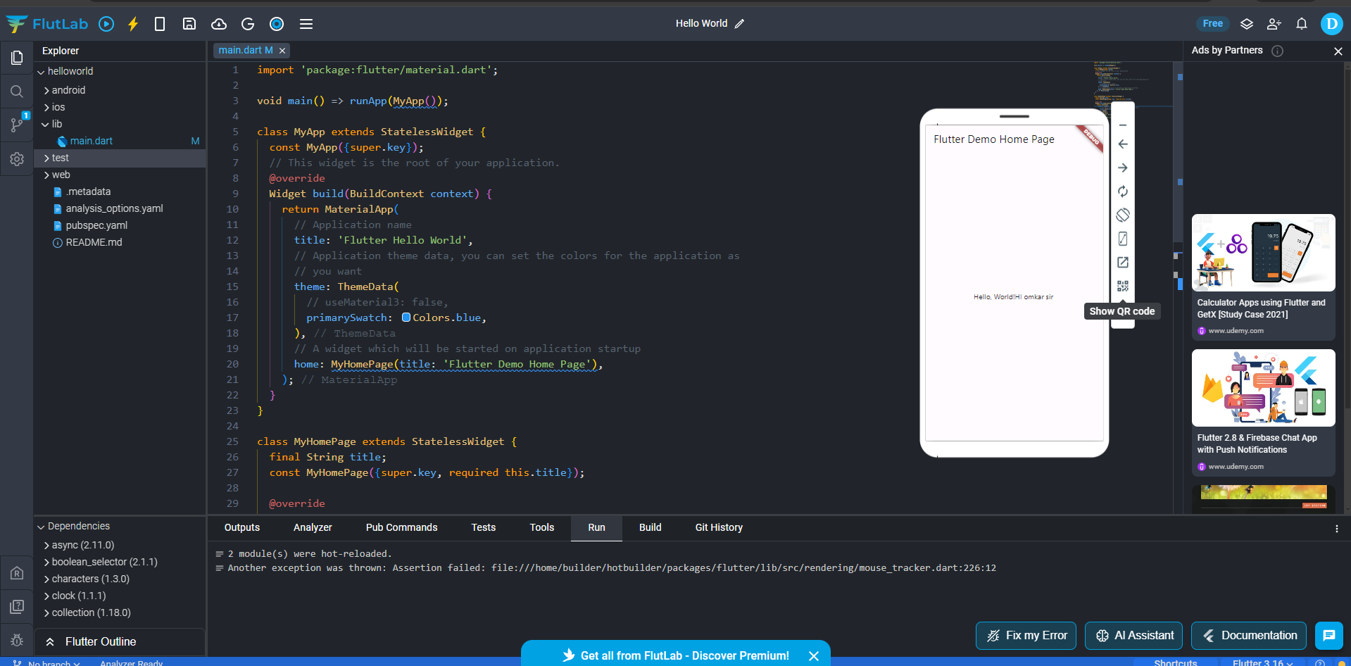

**Conclusion:**

In conclusion, Flutter offers a compelling development experience for creating visually stunning, high-performing applications across various platforms. With its intuitive widget system, modern Dart language, single codebase advantage, hot reload functionality, and smooth performance, Flutter empowers developers to build robust apps efficiently. If you're looking for a framework to streamline your mobile, web, or desktop app development process, Flutter is definitely worth considering.